AI ASSISTED CODING
Hall Ticket No: 2303A51867
Batch:13

Assignment-1.4
Task-1. AI-Generated Logic Without Modularization (Prime Number Check
Without Functions)
Prompt
#Generate a proper python code to check weather the given number is prime or not without using any functions

Code
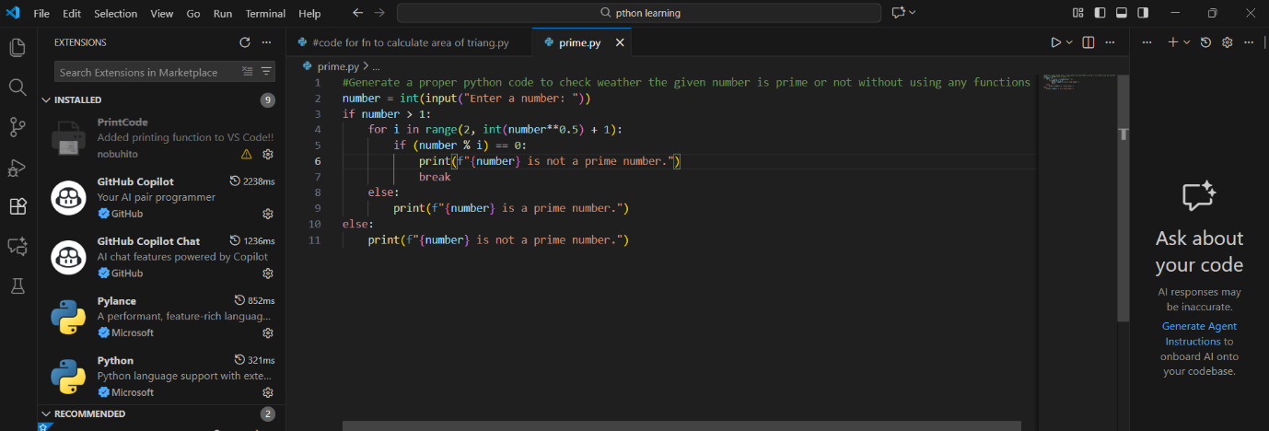
Output:
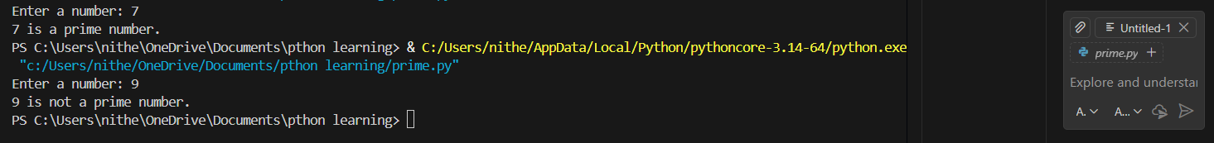
Justification:
This program checks whether a given number is prime using direct conditional logic without defining any functions.
All computations are performed sequentially in a single block, making the logic easy to follow and suitable for beginners.

Task-2. Efficiency & Logic Optimization (Cleanup)
Prompt
#Improve readability while keeping the logic simple and improve efficiency of the code by reducing iterations also minimize the code length
Code:
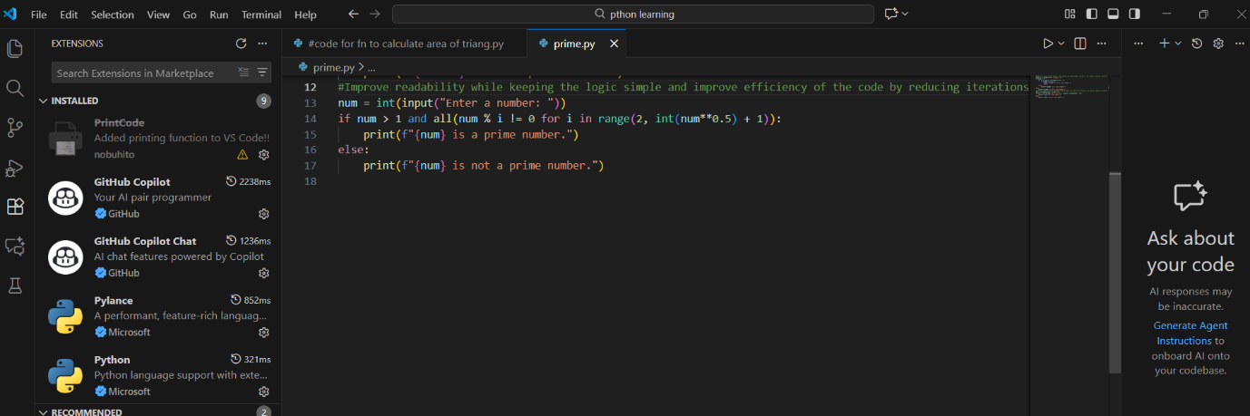
Output:
Justification:
The optimized script improves performance by reducing unnecessary iterations and limiting the loop range, enabling faster execution for larger input values.
Early termination and simplified conditions lower the overall time complexity while maintaining correct prime number validation.

Task-3. Modular Design Using AI Assistance (Prime Number Check Using
Functions)
Prompt:
#The function must return a Boolean value (True if prime, False otherwise)

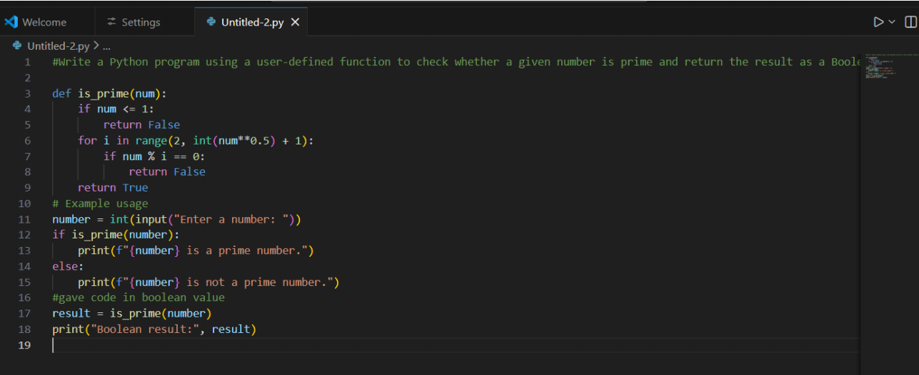
Output:
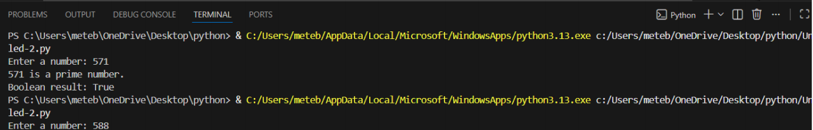
Justification:
Using a user-defined function makes the prime-checking logic reusable across multiple modules, improving code modularity and maintainability. Returning a Boolean value enables easy integration with conditional statements and other program components.

Task-4: Comparative Analysis –With vs Without Functions
Prompt:
# Compare both code with function without function Analyze and compare two Python programs for checking whether a number is prime

Code:
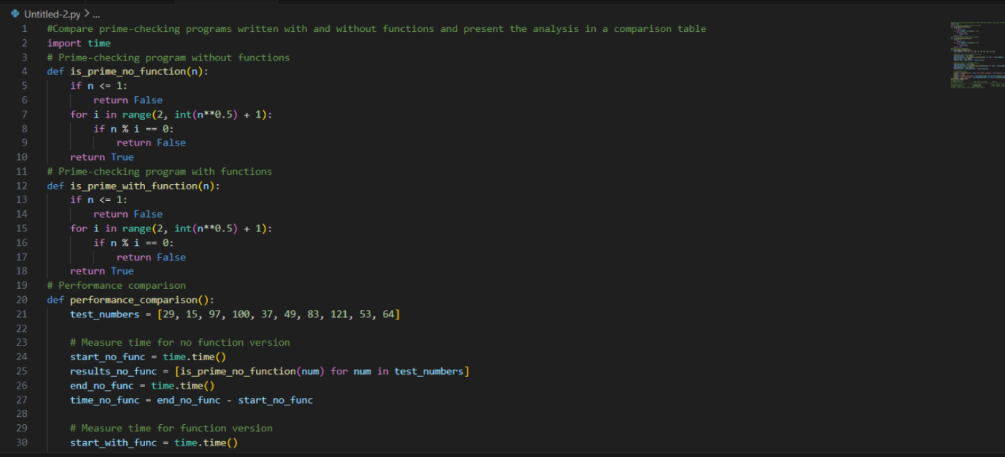
Output:
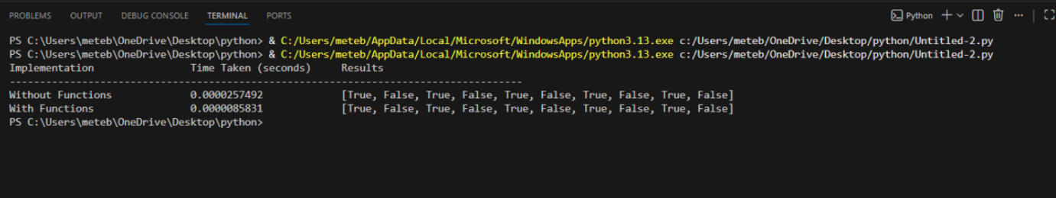
Justification:
Programs written with functions offer better code clarity by separating logic into well-defined blocks, making them easier to read and understand. Function-based designs improve reusability and debugging ease, as changes or fixes can be applied in one place without affecting the entire code.

Task-5: AI-Generated Iterative vs Recursive Fibonacci Approaches (Different
Algorithmic Approaches to Prime Checking)

Prompt: Prime Number Check – Basic vs Optimized Approach
Code:
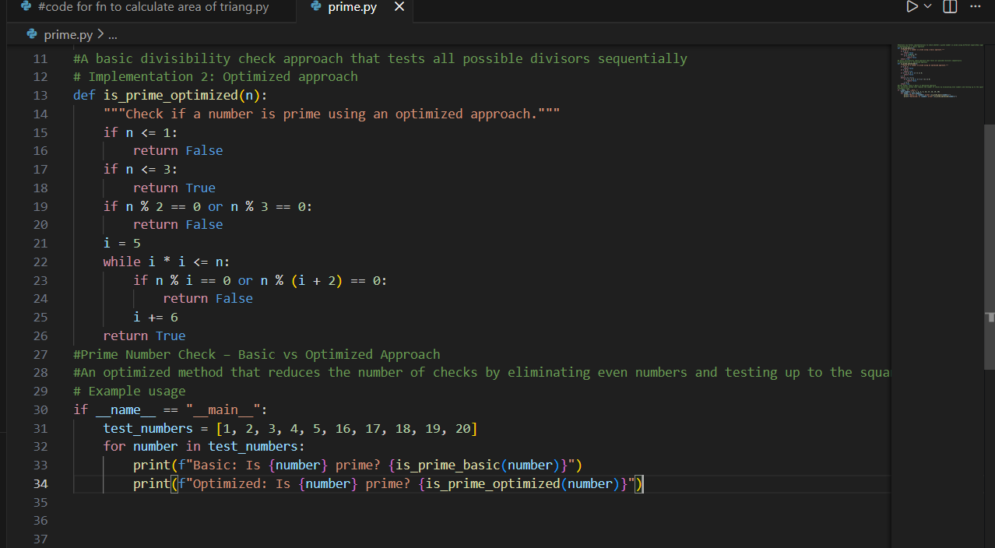
Output:
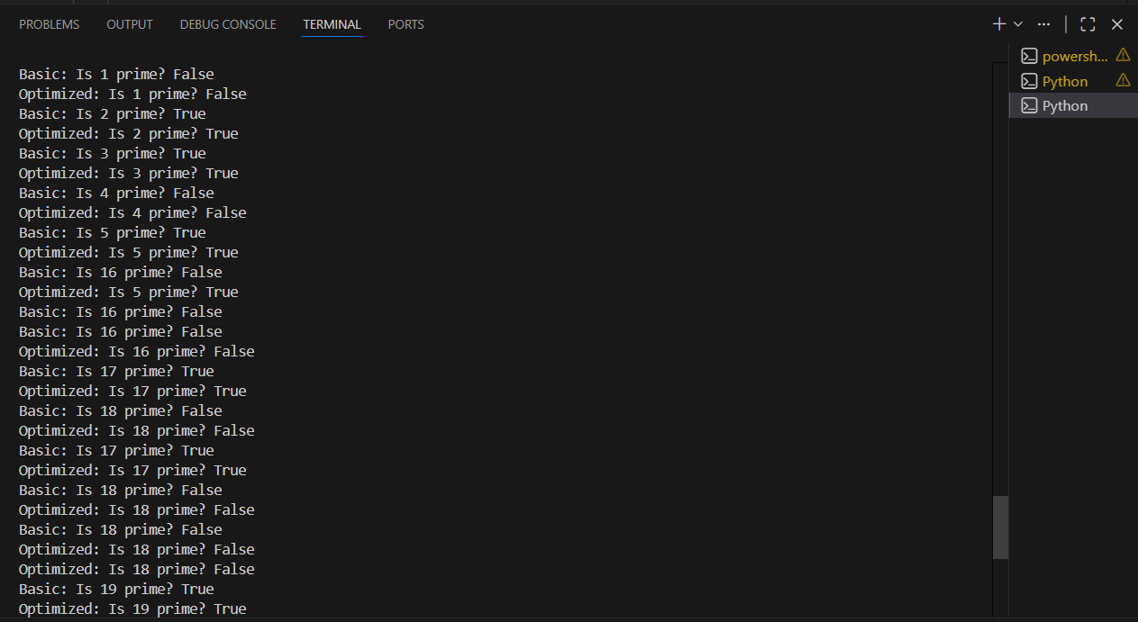

Justification:
The basic approach checks divisibility up to N−1, resulting in unnecessary iterations and higher time complexity.
The optimized approach checks only up to √N because any factor larger than √N must have a corresponding smaller factor.

